CIS2344 Algorithms Processes and Data

# Practical 20: recursion

## Activity 1 (Portfolio Task):

Implement recursively the [Sierpiński carpet](https://en.wikipedia.org/wiki/Sierpi%C5%84ski_carpet). More specifically, a recursive function will take as input a 2D array of characters (i.e. char[][] board) of size 3n X 3n, where 1 ≤n ≤ 5 (i.e. 3x3, 9x9, 27x27, 81x81, 243x243). The 2D array can be divided into 9 sub-arrays of size 3n-1 x 3n-1, e.g. a 3x3 array can be divided into 9 sub-arrays of size 1x1:

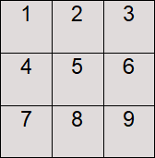

We can now remove the middle sub-array (i.e. sub-array 5) resulting in the following array:

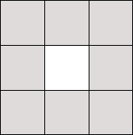

For larger arrays this process is applied recursively, e.g. a 9x9 array:

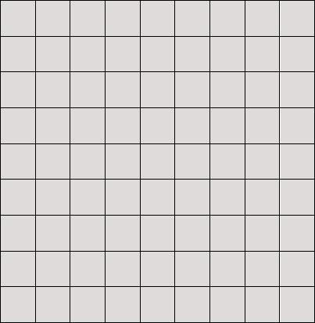

First, remove the middle 3x3 sub-array:

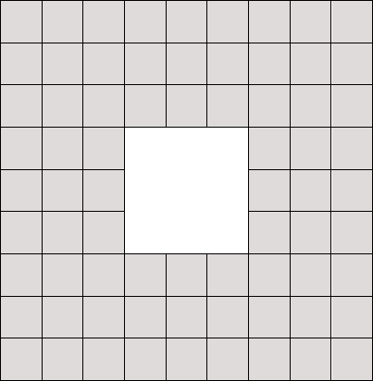

Then, apply the process recursively on the 8 sub-arrays of size 3x3 (removing arrays of size 1x1):

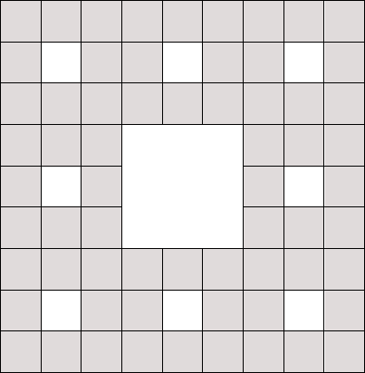

For an array of size 27x27, the Sierpiński carpet would be as follows (remove 9x9 sub-array, then 3x3 sub-arrays, and then 1x1 sub-arrays):

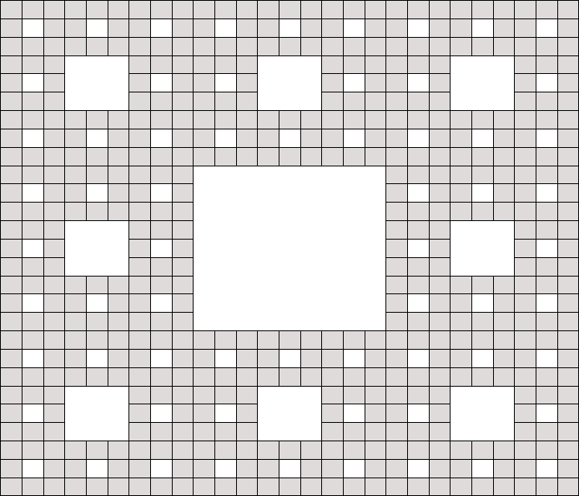

The array or characters is initialised by setting each cell to ‘*’, while removing a sub-array sets the corresponding cells to ‘ ’. File ‘Sierpinski_Carpet.zip’ contains a Sierpiński carpet for sizes 3x3, 9x9, 27x27, 81x81 and 243x243 (in case sizes 81x81 and 243x243 are unreadable in your text editor, then you will need to reduce the font).

Implement class SierpinskiCarpet, which:

* Stores a 2D array of characters (i.e. char[][] board) as well as the dimension size of the array (i.e. 3, 9, 27, 81 or 243)
* Initializes the board with characters ‘*’
* Calls a recursive function that removes sub-arrays (by setting cells to ‘ ’) resulting in a Sierpiński carpet (note that the recursive function must take the 2D array as input, but can take additional parameters that facilitate the recursion)
* Prints the Sierpiński carpet

Discuss your progress with your Tutor during practical sessions.

**What to include in your Portfolio:**

* **Report:** Describe in your report which parts of **Activity 1** have been successfully implemented
* **IntelliJ Project:** Include your Java code for **Activity 1** in your IntelliJ project under package "Practical_20"